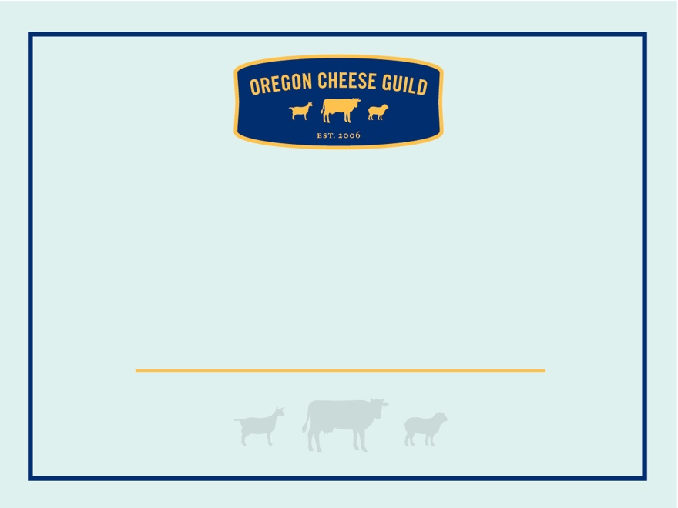

**OREGON CHEESE**

CREAMERY GOES HERE

**OREGON CHEESE**

CREAMERY GOES HERE

**OREGON CHEESE**

CREAMERY GOES HERE

**OREGON CHEESE**

CREAMERY GOES HERE

**OREGON CHEESE**

CREAMERY GOES HERE

**OREGON CHEESE**

CREAMERY GOES HERE